Step #1: Unbox Cisco phone and assemble as below (Do not unplug your old phone set until later step)
Phone stand that comes in phone box that you attach to back of your new Cisco phone set.
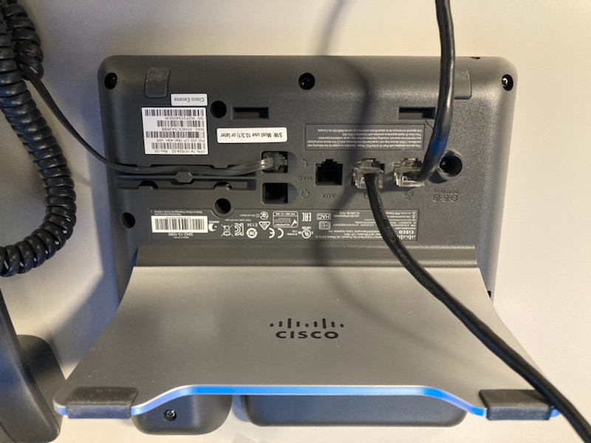
This end
plugs into
your
computer

( C ) Handset cord that plugs into this outlet
on the back of your phone

(B) Cord plugs into this outlet on your new Cisco phone set.
Then other end of this cord will now plug into
your computer
(A)
Unplug this cord from back of your existing computer and now plug into this outlet on the back of your new Cisco phone set.

Step # 2: Wait for new phone to boot up – Sample Screen below will show your Extension #
- You should hear a dial tone

Step #3: Disabling Call Forwarding
NOTE: On a 7841 telephone Call Forwarding can only be disabled from the phone for the primary number. If a phone has 2 or more numbers a phone system admin will have to disable the call forwarding for the additional lines.
- On your new phone go to 4th button that is on the far-right button, below your screen and press it. This is a rubber button on the phone below the screen (not on the screen)
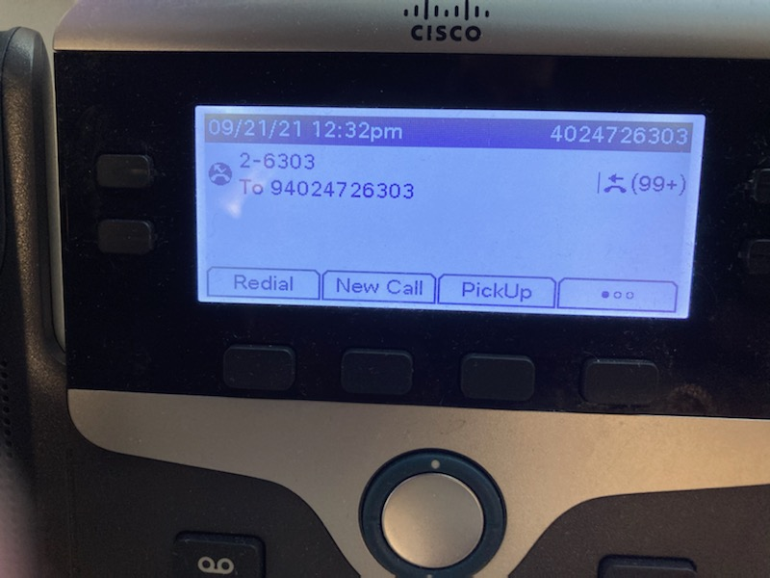

- Then go to the 2nd rubber button from Left below the “Fwd Off” and press this rubber button.
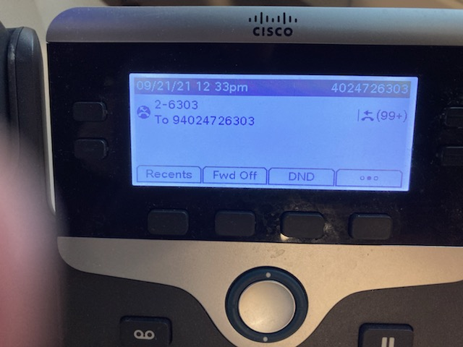

- Then your screen should appear as:
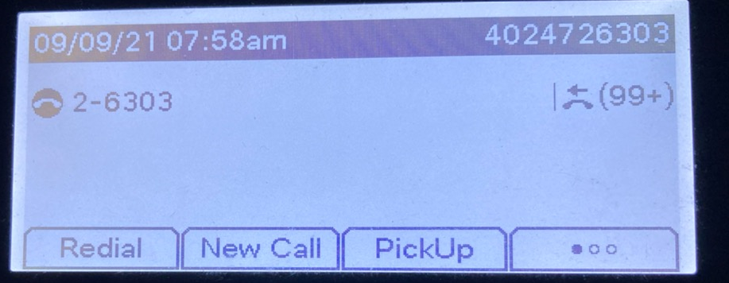

Step # 4:
- Go to your old phone set, pick up receiver and dial: “star, 72 then 5 then dial your 10-digit office phone number.
Example: if your phone # is 402-472-1234. You would dial: * 72 5 402-472-1234

- You will hear a beep.
- Hang up and your old phone set and it is now forwarded to your new phone set
- From your New Cisco phone set, dial any outside phone # to make sure your new phone works. You can also call your office phone # from any other phone and your new phone should ring.
Note: If for some reason you need to un-forward your new phone set back to your old phone set simply dial pound, 72 then your 10-digit phone number. (e.g.: # 72 402-472-1234)

Step # 5:
Unplug your old phone set from the wall and wrap old phone set cord around old phone and put old phone on your office floor outside your office and it will be picked up later.

